Embedded Systems Design

20153208 Lee soyoung

PROJECT : SMART_MIRROR

What is Smart Mirror??

* A smart mirror that shows you what you want using a mirror as a display monitor

The Motivation of proposal

* Difficult to manage time while watching the mirror

What you want to implement

1. Mirror is to display monitor
2. The mirror is show that time, date , weather ,etc…..
3. We can control the mirror through voice recognition.
4. Time reminder and smart phone status display via mirror

Actual production

1.Hardware Marking

- Necessary article : , LCD monitor , Clear glass , Mirror film,Wood, Black tape,5mm Non-woven,tool etc….

1. Attach half mirror film of same size on transparent glass of 45 * 55 size
2. Remove the air bubbles between the mirror film and the transparent glass by pushing them down.
3. Prepared wood is cut into 57 * 2.5 * 2.5 size and 44 * 2.5 * 2.5 size and make four each
4. Use wood to make two rectangular frames.
5. Put the glass with the mirror film between two frames to nail it.
6. Fill the space created by the mirror with nonwoven fabric and nail on the edge of the mirror.
7. Remove the bezel of the monitor with a flat screwdriver.
8. Cover the bezel part of the monitor and the back of the mirror with black tape.

Image

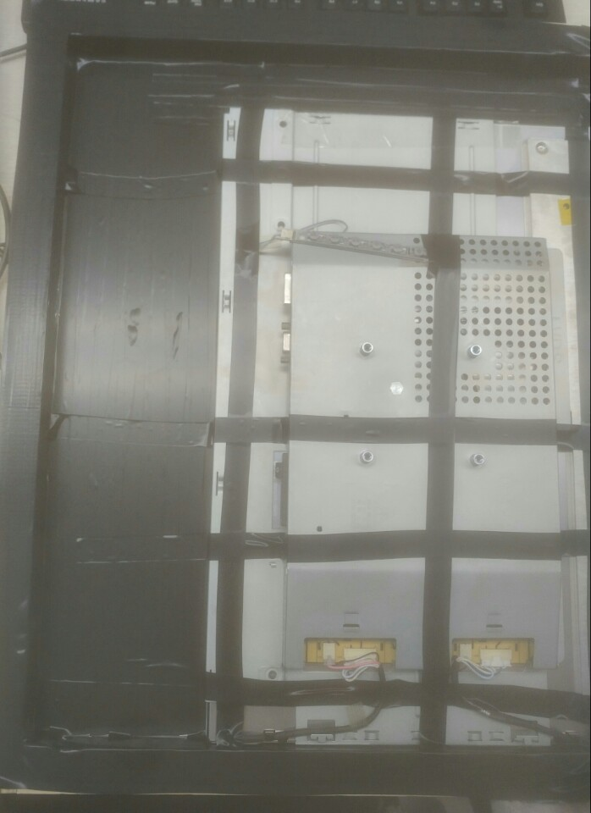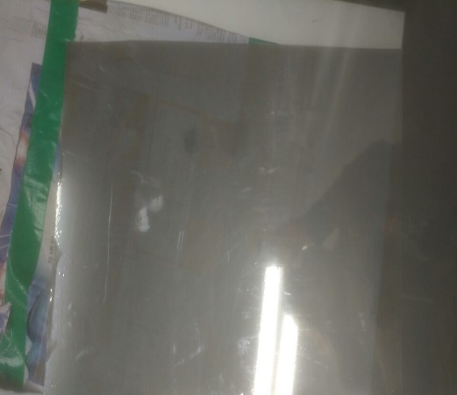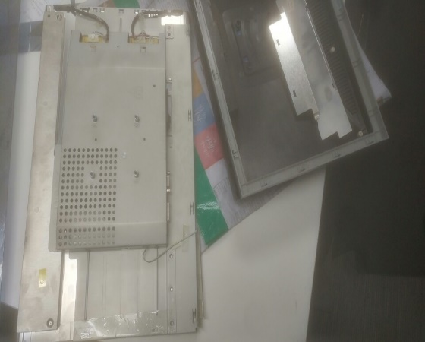

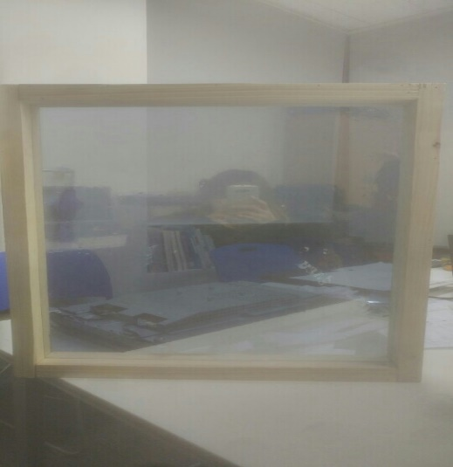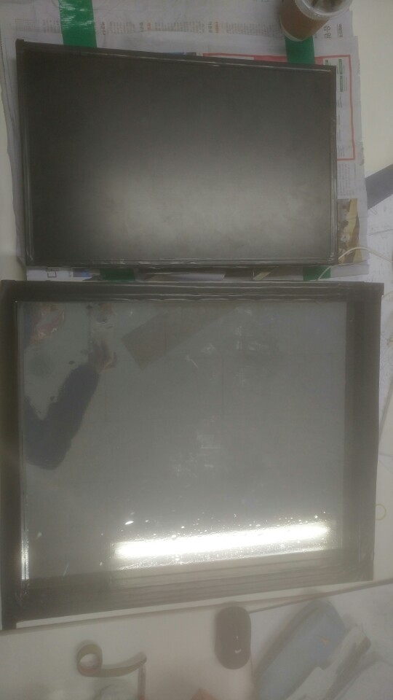

2.Software production

- Necessary article : Raspberry Pi ,LCD monitor , Speaker, Usb microphone etc…

2-1.Raspberry Pi Set

1. Raspbian jessie downloads and OS seting
2. Sudo rapi-config : lanquage and reqional set
3. Sudo passwd root : passwd set
4. Wifi set : iwconfig -> iwlist wlan0 scan -> su - -> wpa_passphrase wifi_name wifi_pw >> /etc/wpa_supplicant/wpa_supplicant.conf -> Su pi -> sudo ifup wlan0
5. Korean-fonts set : sudo apt-get install ttf-unfonts-core -> sudo apt-get install ibus-hangul
6. Speaker set : sudo raspi-config -> advanced Options -> 1.Force 3.5mm jack -> finish -> you can test aplay test.wav
7. Microphone set : sudo vi usr/share/alsa/alsa.conf -> defaults.ctl.card 1,daefaults.pcm.card 1
8. Display rotation set : sudo vi/boot/config.txt -> (bottom line) displayrotate=1
9. Other setting url reference : (http://jeongchul.tistory.com/425?category=552705)

2-2. Smart Mirror Display

1. Node download and set : wget <https://nodejs.org/dist/v.4.0.0-linux-armv7l.tar.gz> -> tar -xvf this file
2. Github Opensource load : make dictory -> git clone <https://github.com/evancohen/smart-mirror.git>
3. Node-module load : npm install
4. Test-smart-mirror : cp main.js -> npm start
5. Customizing open source css, html, and js using Eclipse tools

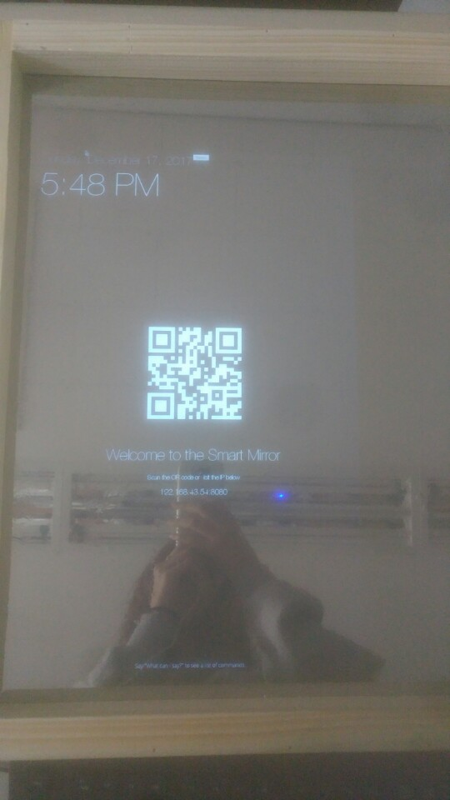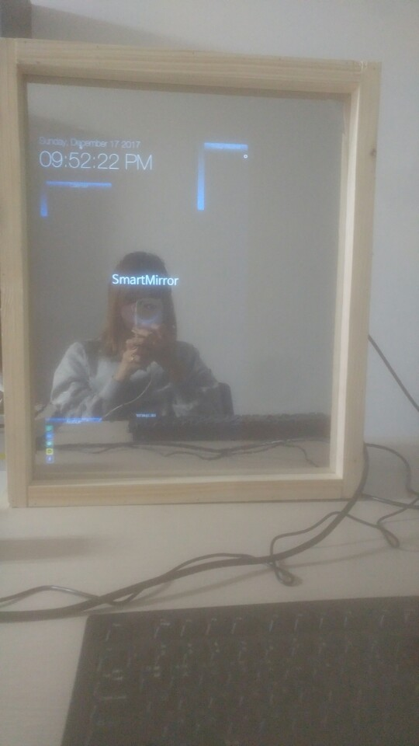

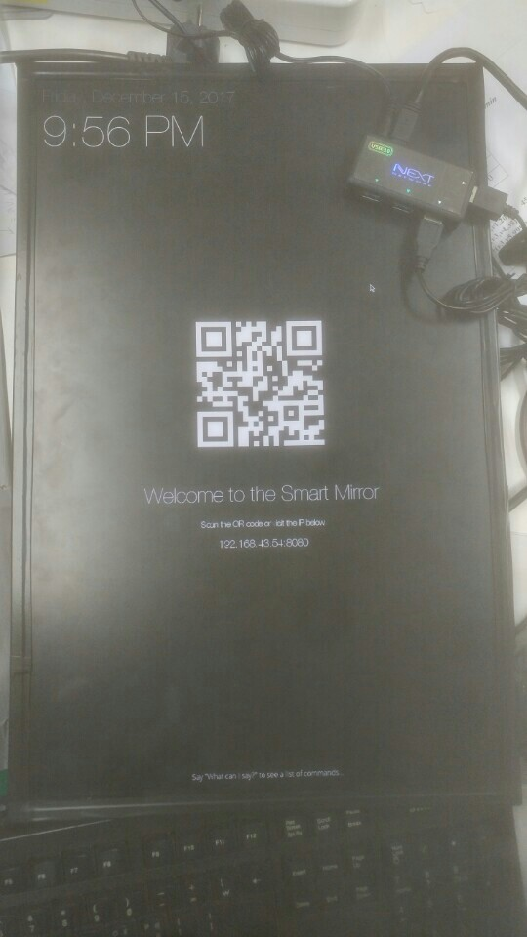

2-3. Voice recognition.

1. Attempt to implement speech recognition using nodejs
2. Attempt to implement speech recognition using python

* Failed to implement : I am sorry that the period is short.